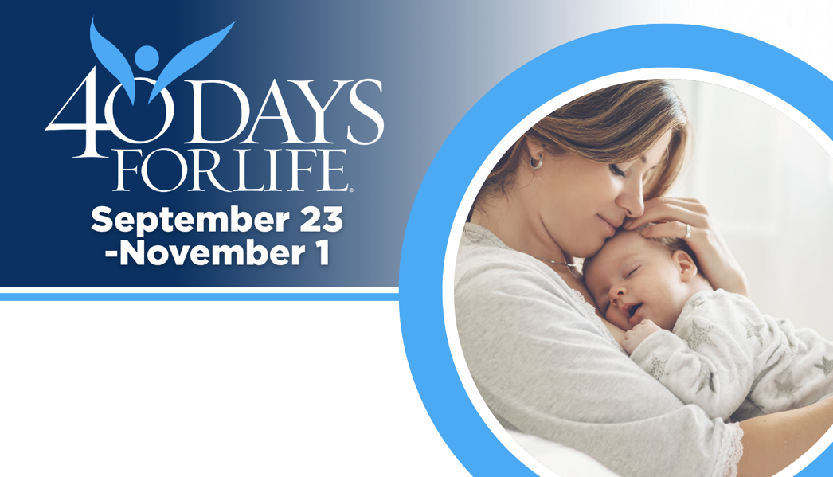
Help Save Lives from Abortion
in Lynnwood
Help protect mothers and children by joining this
worldwide mobilization! Through prayer and fasting,
peaceful vigils and community outreach, 40 Days for Life
has inspired 1,000,000+ volunteers! And saved 26,000 babies!

Vigil location: Public sidewalk outside
Lynnwood Planned Parenthood, 19505 76th Ave W

Sign up to come to the sidewalk to pray:
7 am to 7 pm, Mon - Sat
Local contact: Rebecca A.
40daysforlife.lynnwood@gmail.com

Be a sign of hope and help. Come to the sidewalk.
Participate in this peaceful effort
rooted in prayer & fasting.

Learn more and sign up by visiting our campaign:
40daysforlife.com/Lynnwood
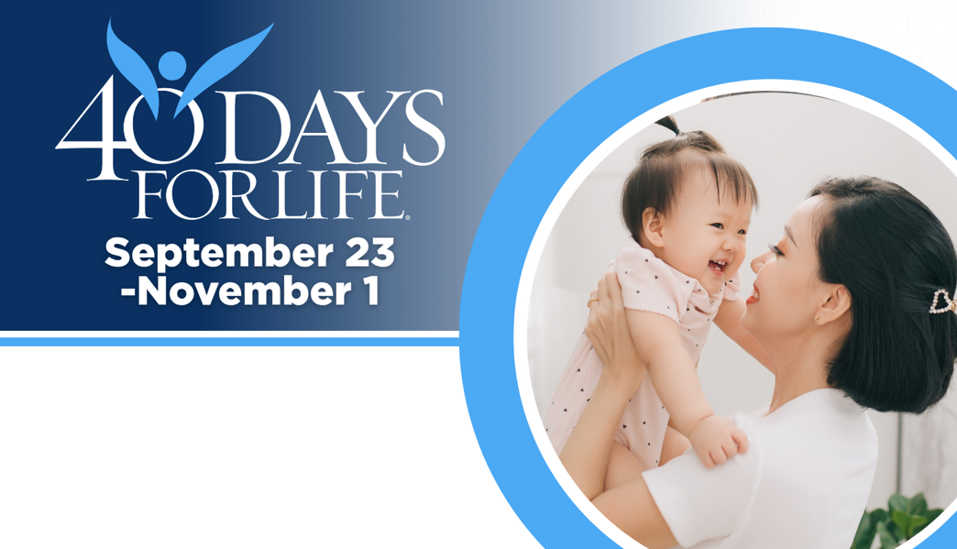
Help Save Lives from Abortion
in Lynnwood
Help protect mothers and children by joining this
worldwide mobilization! Through prayer and fasting,
peaceful vigils and community outreach, 40 Days for Life
has inspired 1,000,000+ volunteers! And saved 26,000 babies!

Vigil location: Public sidewalk outside
Lynnwood Planned Parenthood, 19505 76th Ave W

Sign up to come to the sidewalk to pray:
7 am to 7 pm, Mon - Sat
Local contact: Rebecca A.
40daysforlife.lynnwood@gmail.com

Be a sign of hope and help. Come to the sidewalk.
Participate in this peaceful effort
rooted in prayer & fasting.

Learn more and sign up by visiting our campaign:
40daysforlife.com/Lynnwood
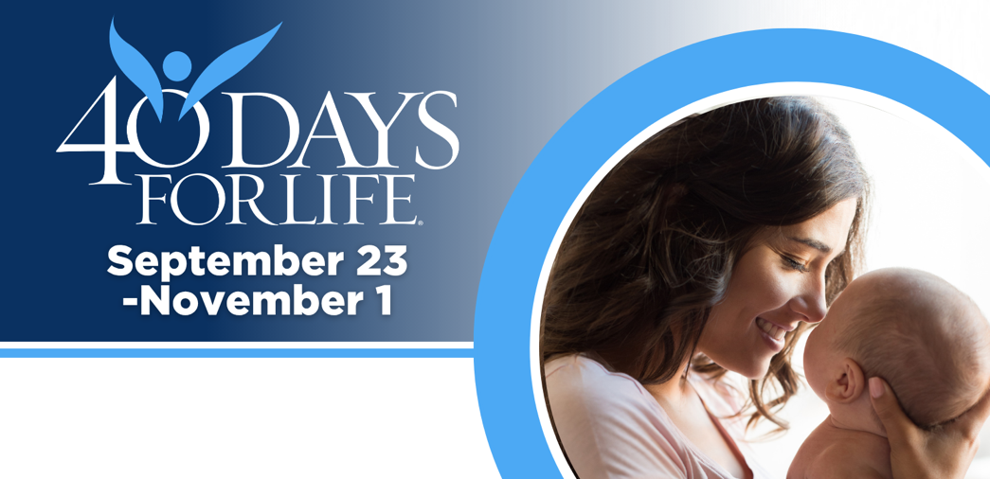
Help Save Lives from Abortion
in Lynnwood

Help protect mothers and children by joining this
worldwide mobilization! Through prayer and fasting,
peaceful vigils and community outreach, 40 Days for Life
has inspired 1,000,000+ volunteers! And saved 26,000 babies!

Vigil location: Public sidewalk outside
Lynnwood Planned Parenthood, 19505 76th Ave W

Sign up to come to the sidewalk to pray:
7 am to 7 pm, Mon - Sat
Local contact: Rebecca A.
40daysforlife.lynnwood@gmail.com

Be a sign of hope and help. Come to the sidewalk.
Participate in this peaceful effort
rooted in prayer & fasting.

Learn more and sign up by visiting our campaign:
40daysforlife.com/Lynnwood
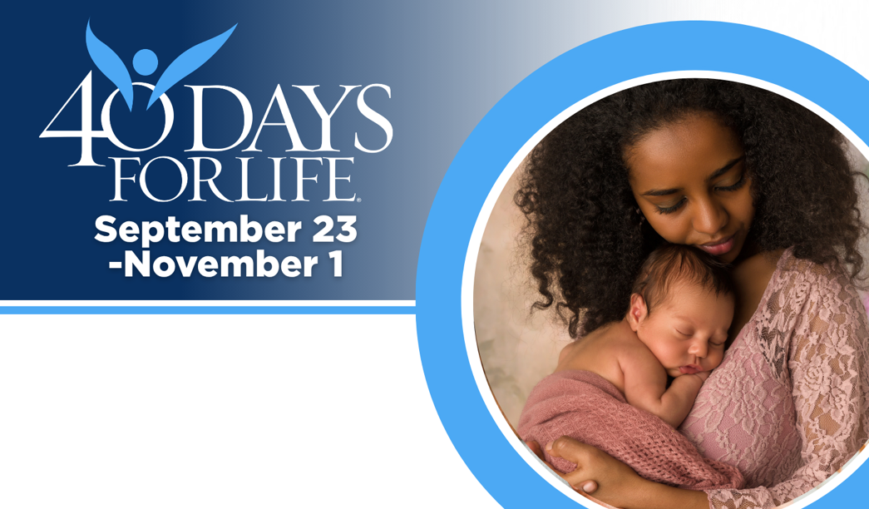
Help Save Lives from Abortion
in Lynnwood

Help protect mothers and children by joining this
worldwide mobilization! Through prayer and fasting,
peaceful vigils and community outreach, 40 Days for Life
has inspired 1,000,000+ volunteers! And saved 26,000 babies!

Vigil location: Public sidewalk outside
Lynnwood Planned Parenthood, 19505 76th Ave W

Sign up to come to the sidewalk to pray:
7 am to 7 pm, Mon - Sat
Local contact: Rebecca A.
40daysforlife.lynnwood@gmail.com

Be a sign of hope and help. Come to the sidewalk.
Participate in this peaceful effort
rooted in prayer & fasting.

Learn more and sign up by visiting our campaign:
40daysforlife.com/Lynnwood

